Every Common Core Standard Related to Technology and Digital Media
Assembled by Ben Rimes, K-12 Instructional Technology Coordinator, Mattawan Consolidated School
last updated: May 19th, 2013

This work is licensed under a Creative Commons Attribution-NonCommercial-ShareAlike 3.0 Unported License.

- Key Design Considerations
- Students Who are College and Career Ready in Reading, Writing, Speaking, Listening, and Language
  - College and Career Readiness Anchor Standards for Writing
  - College and Career Readiness Anchor Standards for Speaking and Listening
- Reading Standards
- Writing Standards
- Language Standards
- Speaking & Listening Standards
- Range, Quality, and Complexity of Student Reading
- Literacy Standards for Literacy in History/Social Studies, Science, and Technical Subjects
  - Production and Distribution of Writing
  - Research to Build and Present Knowledge
  - Reading Standards for Literacy in History/Social Studies 6–12
- Standards for Mathematical Practice
- Connecting the Standards for Mathematical Practice to the Standards for Mathematical Content

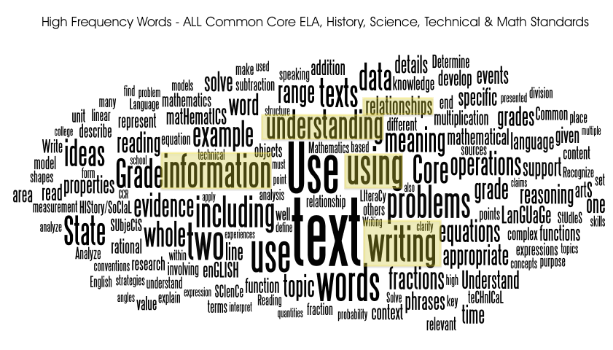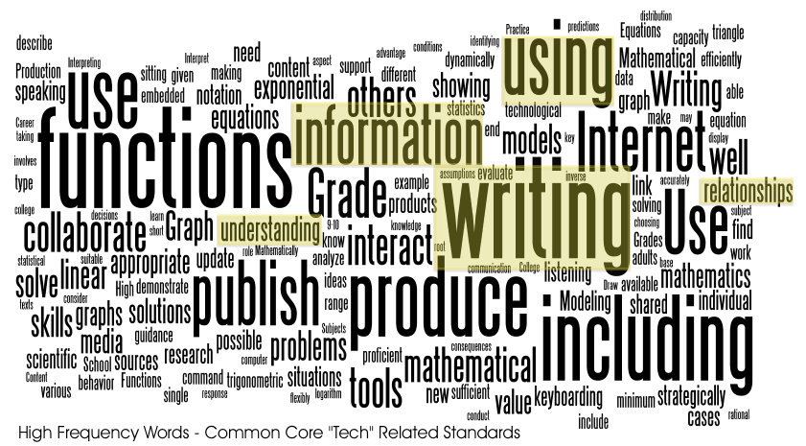

Key Design Considerations

Research and media skills blended into the Standards as a whole
“To be ready for college, workforce training, and life in a technological society, students need the ability to gather, comprehend, evaluate, synthesize, and report on information and ideas, to conduct original research in order to answer questions or solve problems, and to analyze and create a high volume and extensive range of print and nonprint texts in media forms old and new. The need to conduct research and to produce and consume media is embedded into every aspect of today’s curriculum. In like fashion, research and media skills and understandings are embedded throughout the Standards rather than treated in a separate section.”

Accommodations
“The Standards should also be read as allowing for the widest possible range of students to participate fully from the outset and as permitting appropriate accommodations to ensure maximum participation of students with special education needs. For example, for students with disabilities reading should allow for the use of Braille, screen-reader technology, or other assistive devices, while writing should include the use of a scribe, computer, or speech-to-text technology. In a similar vein, speaking and listening should be interpreted broadly to include sign language.”

Note on range and content of student speaking and listening
“New technologies have broadened and expanded the role that speaking and listening play in acquiring and sharing knowledge and have tightened their link to other forms of communication. Digital texts confront students with the potential for continually updated content and dynamically changing combinations of words, graphics, images, hyperlinks, and embedded video and audio.”

“For students, writing is a key means of asserting and defending claims, showing what they know about a subject, and conveying what they have experienced, imagined, thought, and felt. To be college- and career ready writers, students must take task, purpose, and audience into careful consideration, choosing words, information, structures, and formats deliberately. They need to know how to combine elements of different kinds of writing—for example, to use narrative strategies within argument and explanation within narrative—to produce complex and nuanced writing. They need to be able to use technology strategically when creating, refining, and collaborating on writing. They have to become adept at gathering information, evaluating sources, and citing material accurately, reporting findings from their research and analysis of sources in a clear and cogent manner. They must have the flexibility, concentration, and fluency to produce high-quality first draft text under a tight deadline as well as the capacity to revisit and make improvements to a piece of writing over multiple drafts when circumstances encourage or require it.”

Students Who are College and Career Ready in Reading, Writing, Speaking, Listening, and Language:

They demonstrate independence.
Students can, without significant scaffolding, comprehend and evaluate complex texts across a range of types and disciplines, and they can construct effective arguments and convey intricate or multifaceted information. Likewise, students are able independently to discern a speaker’s key points, request clarification, and ask relevant questions. They build on others’ ideas, articulate their own ideas, and confirm they have been understood. Without prompting, they demonstrate command of standard English and acquire and use a wide-ranging vocabulary. More broadly, they become self-directed learners, effectively seeking out and using resources to assist them, including teachers, peers, and print and digital reference materials.

They use technology and digital media strategically and capably
“Students employ technology thoughtfully to enhance their reading, writing, speaking, listening, and language use. They tailor their searches online to acquire useful information efficiently, and they integrate what they learn using technology with what they learn offline. They are familiar with the strengths and limitations of various technological tools and mediums and can select and use those best suited to their communication goals.”

College and Career Readiness Anchor Standards for Writing

Production and distribution of Writing

K-5
6. Use technology, including the Internet, to produce and publish writing and to interact and collaborate with others

6-12
6. Use technology, including the Internet, to produce and publish writing and to interact and collaborate with others

Research to Build and Present Knowledge

K-5
8. Gather relevant information from multiple print and digital sources, assess the credibility and accuracy of each source, and integrate the information while avoiding plagiarism.

6-12
8. Gather relevant information from multiple print and digital sources, assess the credibility and accuracy of each source, and integrate the information while avoiding plagiarism.

College and Career Readiness Anchor Standards for Speaking and Listening

Presentation of Knowledge and Ideas

K-5
5. Make strategic use of digital media and visual displays of data to express information and enhance understanding of presentations.

6-12
5. Make strategic use of digital media and visual displays of data to express information and enhance understanding of presentations.

Reading Standards

Reading Standards for Literature

Integration of Knowledge and Ideas
Grade 2 Students
Use information gained from the illustrations and words in a print or digital text to demonstrate understanding of its characters, setting, or plot.

Reading Standards for Informational Text

Integration of Knowledge and Ideas
Grade 5 Students
Draw on information from multiple print or digital sources, demonstrating the ability to locate an answer to a question quickly or to solve a problem efficiently.

Grade 8 Students
7. Evaluate the advantages and disadvantages of using different mediums (e.g., print or digital text, video, multimedia) to present a particular topic or idea.

Writing Standards

Production and distribution of Writing

K Students
6. With guidance and support from adults, explore a variety of digital tools to produce and publish writing, including in collaboration with peers.
ABC Book with photos/drawings/sentences/narration via iPad (Educreations, ShowMe), Computer (KidPix, KidSpiration),

Grade 2 Students
6. With guidance and support from adults, explore a variety of digital tools to produce and publish writing, including in collaboration with peers.
Research Reports, Blogging, ePals, Fun Facts Shared via Voki,
Grade 3 Students
6. With guidance and support from adults, explore a variety of digital tools to produce and publish writing, including in collaboration with peers.
Research Reports, Blogging, ePals, Fun Facts Shared via Voki, Create review materials on Zondle, Write About This app on iPad (random prompts), S’More (digital flyers)

Grade 3 Students
With guidance and support from adults, use technology to produce and publish writing (using keyboarding skills) as well as to interact and collaborate with others
Write About This app with bluetooth keyboard for iPad, Edmodo for collaboration, S’More (digital flyers)

Grade 4 Students
With some guidance and support from adults, use technology, including the Internet, to produce and publish writing as well as to interact and collaborate with others; demonstrate sufficient command of keyboarding skills to type a minimum of one page in a single sitting

Grade 5 Students
With some guidance and support from adults, use technology, including the Internet, to produce and publish writing as well as to interact and collaborate with others; demonstrate sufficient command of keyboarding skills to type a minimum of two pages in a single sitting

Grade 6 Students
Use technology, including the Internet, to produce and publish writing as well as to interact and collaborate with others; demonstrate sufficient command of keyboarding skills to type a minimum of three pages in a single sitting

Grade 7 Students
Use technology, including the Internet, to produce and publish writing and link to and cite sources as well as to interact and collaborate with others, including linking to and citing sources

Grade 8 Students
Use technology, including the Internet, to produce and publish writing and present the relationships between information and ideas efficiently as well as to interact and collaborate with others

Grade 9-10 Students
Use technology, including the Internet, to produce, publish, and update individual or shared writing products, taking advantage of technology’s capacity to link to other information and to display information flexibly and dynamically

Grade 11-12 Students
Use technology, including the Internet, to produce, publish, and update individual or shared writing products in response to ongoing feedback, including new arguments or information

Research to Build and Present Knowledge
Grade 3 Students
8. Recall information from experiences or gather information from print and digital sources; take brief notes on sources and sort evidence into provided categories.

Grade 4 Students
8. Recall relevant information from experiences or gather relevant information from print and digital sources; take notes and categorize information, and provide a list of sources.

Grade 5 Students
8. Recall relevant information from experiences or gather relevant information from print and digital sources; summarize or paraphrase information in notes and finished work, and provide a list of sources.

Grade 6 Students
8. Gather relevant information from multiple print and digital sources; assess the credibility of each source; and quote or paraphrase the data and conclusions of others while avoiding plagiarism and providing basic bibliographic information for sources.

Grade 7 Students
8. Gather relevant information from multiple print and digital sources, using search terms effectively; assess the credibility and accuracy of each source; and quote or paraphrase the data and conclusions of others while avoiding plagiarism and following a standard format for citation.

Grade 8 Students
8. Gather relevant information from multiple print and digital sources, using search terms effectively; assess the credibility and accuracy of each source; and quote or paraphrase the data and conclusions of others while avoiding plagiarism and following a standard format for citation.

Grade 9-10 Students
8. Gather relevant information from multiple authoritative print and digital sources, using advanced searches effectively; assess the usefulness of each source in answering the research question; integrate information into the text selectively to maintain the flow of ideas, avoiding plagiarism and following a standard format for citation.

Grade 11-12 Students
8. Gather relevant information from multiple authoritative print and digital sources, using advanced searches effectively; assess the strengths and limitations of each source in terms of the task, purpose, and audience; integrate information into the text selectively to maintain the flow of ideas, avoiding plagiarism and overreliance on any one source and following a standard format for citation.

Language Standards

Vocabulary acquisition and Use

Grade 2 Students
4.e Use glossaries and beginning dictionaries, both print and digital, to determine or clarify the meaning of words and phrases.

Grade 3 Students
4.e Use glossaries or beginning dictionaries, both print and digital, to determine or clarify the meaning of words and phrases.

Grade 4 Students
4.c Consult reference materials (e.g., dictionaries, glossaries, thesauruses), both print and digital, to find the pronunciation and determine or clarify the precise meaning of key words and phrases.

Grade 5 Students
4.c Consult reference materials (e.g., dictionaries, glossaries, thesauruses), both print and digital, to find the pronunciation and determine or clarify the precise meaning of key words and phrases.

Grade 6 Students
4.c Consult reference materials (e.g., dictionaries, glossaries, thesauruses), both print and digital, to find the pronunciation of a word or determine or clarify its precise meaning or its part of speech.

Grade 7 Students
4.c Consult general and specialized reference materials (e.g., dictionaries, glossaries, thesauruses), both print and digital, to find the pronunciation of a word or determine or clarify its precise meaning or its part of speech.

Grade 8 Students
4.c Consult general and specialized reference materials (e.g., dictionaries, glossaries, thesauruses), both print and digital, to find the pronunciation of a word or determine or clarify its precise meaning or its part of speech.

Grade 9-10 Students
4.c Consult general and specialized reference materials (e.g., dictionaries, glossaries, thesauruses), both print and digital, to find the pronunciation of a word or determine or clarify its precise meaning, its part of speech, or its etymology.

Grade 11-12 Students
4.c Consult general and specialized reference materials (e.g., dictionaries, glossaries, thesauruses), both print and digital, to find the pronunciation of a word or determine or clarify its precise meaning, its part of speech, its etymology, or its standard usage.

Speaking & Listening Standards

Presentation of Knowledge and Ideas
Grade 9-10 Students
5. Make strategic use of digital media (e.g., textual, graphical, audio, visual, and interactive elements) in presentations to enhance understanding of findings, reasoning, and evidence and to add interest.

Grade 11-12 Students
5. Make strategic use of digital media (e.g., textual, graphical, audio, visual, and interactive elements) in presentations to enhance understanding of findings, reasoning, and evidence and to add interest.

Range, Quality, and Complexity of Student Reading

Literary nonfiction and Historical, Scientific, and technical texts

K-5
Includes biographies and autobiographies; books about history, social studies, science, and the arts; technical texts, including directions, forms, and information displayed in graphs, charts, or maps; and digital sources on a range of topics

6-12
Includes the subgenres of exposition, argument, and functional text in the form of personal essays, speeches, opinion pieces, essays about art or literature, biographies, memoirs, journalism, and historical, scientific, technical, or economic accounts (including digital sources) written for a broad audience

Literacy Standards in History/Social Studies, Science, and Technical Subjects 6–12

(Technical Subjects – A course devoted to a practical study, such as engineering, technology, design, business, or other workforce-related subject; a technical aspect of a wider field of study, such as art or music.)

Production and Distribution of Writing

Grades 6-8 Students
Use technology, including the Internet, to produce and publish writing and present the relationships between information and ideas clearly and efficiently

Grades 9-10 Students
Use technology, including the Internet, to produce, publish, and update individual or shared writing products, taking advantage of technology’s capacity to link to other information and to display information flexibly and dynamically

Grades 11-12 Students
Use technology, including the Internet, to produce, publish, and update individual or shared writing products in response to ongoing feedback, including new arguments or information

Research to Build and Present Knowledge

Grades 6-8 Students
Gather relevant information from multiple print and digital sources, using search terms effectively; assess the credibility and accuracy of each source; and quote or paraphrase the data and conclusions of others while avoiding plagiarism and following a standard format for citation.

Grades 9-10 Students
Gather relevant information from multiple authoritative print and digital sources, using advanced searches effectively; assess the usefulness of each source in answering the research question; integrate information into the text selectively to maintain the flow of ideas, avoiding plagiarism and following a standard format for citation.

Grades 11-12 Students
Gather relevant information from multiple authoritative print and digital sources, using advanced searches effectively; assess the strengths and limitations of each source in terms of the specific task, purpose, and audience; integrate information into the text selectively to maintain the flow of ideas, avoiding plagiarism and overreliance on any one source and following a standard format for citation.

Reading Standards for Literacy in History/Social Studies 6–12

Integration of Knowledge and Ideas
Grades 6-8 Students
Integrate visual information (e.g., in charts, graphs, photographs, videos, or maps) with other information in print and digital texts.

Grades 9-10 Students
Integrate quantitative or technical analysis (e.g., charts, research data) with qualitative analysis in print or digital text.

Standards for Mathematical Practice

Use appropriate tools strategically
“Mathematically proficient students consider the available tools when solving a mathematical problem. These tools might include pencil and paper, concrete models, a ruler, a protractor, a calculator, a spreadsheet, a computer algebra system, a statistical package, or dynamic geometry software. Proficient students are sufficiently familiar with tools appropriate for their grade or course to make sound decisions about when each of these tools might be helpful, recognizing both the insight to be gained and their limitations. For example, mathematically proficient high school students analyze graphs of functions and solutions generated using a graphing calculator. They detect possible errors by strategically using estimation and other mathematical knowledge. When making mathematical models, they know that technology can enable them to visualize the results of varying assumptions, explore consequences, and compare predictions with data. Mathematically proficient students at various grade levels are able to identify relevant external mathematical resources, such as digital content located on a website, and use them to pose or solve problems. They are able to use technological tools to explore and deepen their understanding of concepts.”

Connecting the Standards for Mathematical Practice to the Standards for Mathematical Content

“The Standards for Mathematical Content are a balanced combination of procedure and understanding. Expectations that begin with the word “understand” are often especially good opportunities to connect the practices to the content. Students who lack understanding of a topic may rely on procedures too heavily. Without a flexible base from which to work, they may be less likely to consider analogous problems, represent problems coherently, justify conclusions, apply the mathematics to practical situations, use technology mindfully to work with the mathematics, explain the mathematics accurately to other students, step back for an overview, or deviate from a known procedure to find a shortcut. In short, a lack of understanding effectively prevents a student from engaging in the mathematical practices.”
Grade 1
Measurement and Data 1.MD

Tell and write time.
3. Tell and write time in hours and half-hours using analog and digital clocks.

Grade 2
Measurement and Data 2.MD

Work with time and money.
7. Tell and write time from analog and digital clocks to the nearest five minutes, using a.m. and p.m.

Grade 7
Geometry 7.G

Draw, construct, and describe geometrical figures and describe the relationships between them
2. Draw (freehand, with ruler and protractor, and with technology) geometric shapes with given conditions. Focus on constructing triangles from three measures of angles or sides, noticing when the conditions determine a unique triangle, more than one triangle, or no triangle

Grade 8
Expressions and Equations 8.EE

Work with radicals and integer exponents
4. Perform operations with numbers expressed in scientific notation, including problems where both decimal and scientific notation are used. Use scientific notation and choose units of appropriate size for measurements of very large or very small quantities (e.g., use millimeters per year for seafloor spreading). Interpret scientific notation that has been generated by technology

Algebra
Reasoning With Equations & Innequalites A-REI

Solve systems of equation
9. (+) Find the inverse of a matrix if it exists and use it to solve systems of linear equations (using technology for matrices of dimension 3 × 3 or greater)

Represent and solve equations and inequalities graphically
11. Explain why the x-coordinates of the points where the graphs of the equations y = f(x) and y = g(x) intersect are the solutions of the equation f(x) = g(x); find the solutions approximately, e.g., using technology to graph the functions, make tables of values, or find successive approximations. Include cases where f(x) and/or g(x) are linear, polynomial, rational, absolute value, exponential, and logarithmic functions.

High School - Functions

Connections to Expressions, Equations, Modeling, and Coordinates
“Determining an output value for a particular input involves evaluating an expression; finding inputs that yield a given output involves solving an equation. Questions about when two functions have the same value for the same input lead to equations, whose solutions can be visualized from the intersection of their graphs. Because functions describe relationships between quantities, they are frequently used in modeling. Sometimes functions are defined by a recursive process, which can be displayed effectively using a spreadsheet or other technology.”

Interpreting Functions F-IF

Analyze functions using different representation
7. Graph functions expressed symbolically and show key features of the graph, by hand in simple cases and using technology for more complicated cases.★
  - Graph linear and quadratic functions and show intercepts, maxima, and minima.
  - Graph square root, cube root, and piecewise-defined functions, including step functions and absolute value functions.
  - Graph polynomial functions, identifying zeros when suitable factorizations are available, and showing end behavior.
  - (+) Graph rational functions, identifying zeros and asymptotes when suitable factorizations are available, and showing end behavior.
  - Graph exponential and logarithmic functions, showing intercepts and end behavior, and trigonometric functions, showing period, midline, and amplitude

Building Functions F-BF

Build new functions from existing function
3. Identify the effect on the graph of replacing f(x) by f(x) + k, k f(x), f(kx), and f(x + k) for specific values of k (both positive and negative); find the value of k given the graphs. Experiment with cases and illustrate an explanation of the effects on the graph using technology. Include recognizing even and odd functions from their graphs and algebraic expressions for them

Linear, Quadratic, and exponential models F-LE

Construct and compare linear, quadratic, and exponential models and solve problem
4. For exponential models, express as a logarithm the solution to ab^{ct} = d where a, c, and d are numbers and the base b is 2, 10, or e; evaluate the logarithm using technology

Trigonometric Function F-TF

Model periodic phenomena with trigonometric function
7. (+) Use inverse functions to solve trigonometric equations that arise in modeling contexts; evaluate the solutions using technology, and interpret them in terms of the context.

High School - Modeling

“Modeling links classroom mathematics and statistics to everyday life, work, and decision-making. Modeling is the process of choosing and using appropriate mathematics and statistics to analyze empirical situations, to understand them better, and to improve decisions. Quantities and their relationships in physical, economic, public policy, social, and everyday situations can be modeled using mathematical and statistical methods. When making mathematical models, technology is valuable for varying assumptions, exploring consequences, and comparing predictions with data.”

“Diagrams of various kinds, spreadsheets and other technology, and algebra are powerful tools for understanding and solving problems drawn from different types of real-world situations.”

High School—Statistics and Probability

“Technology plays an important role in statistics and probability by making it possible to generate plots, regression functions, and correlation coefficients, and to simulate many possible outcomes in a short amount of time.”

Interpreting Categorical and Quantitative data S-ID

Interpret linear model
8. Compute (using technology) and interpret the correlation coefficient of a linear fit

